Practical No 2 : Static and Dynamic Analysis
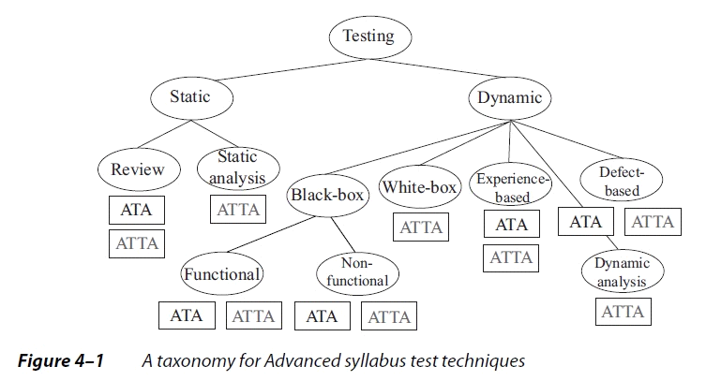

Dynamic tests are broken down into five main types in the Advanced level:
• Black-box (also referred to as specification-based or behavioral), where we test based on the way the system is supposed to work. Black-box tests can further be broken down in two main subtypes, functional and nonfunctional
• White-box (also referred to as structural), where we test based on the way the system is built.
• Experience-based, where we test based on our skills and intuition, along with our experience with similar applications or technologies.
• Defect-based, where we use our understanding of the type of defect targeted by a test as the basis for test design, with tests derived systematically from what is known about the defect.
• Dynamic analysis, where we analyze an application while it is running, usually via some kind of instrumentation in the code.

Equivalence partitioning:
A black-box test design technique in which test cases are designed to execute representatives from equivalence partitions. In principle, test cases are designed to cover each partition at least once.

Objective:
To understand the difference between static and dynamic analysis in the context of software engineering and apply both methods for identifying issues in software, such as bugs, vulnerabilities, and performance bottlenecks.

1. Static Analysis
Static analysis is the process of analyzing code without executing it. It involves examining the source code, bytecode, or binary code to find potential issues like syntax errors, code smells, security vulnerabilities, and performance inefficiencies.
Tools for Static Analysis:
- SonarQube
- Checkmarx
- Pylint (Python)
- PMD (Java)
- ESLint (JavaScript)
- FindBugs (Java)
Code with error ( python )
def calculate_area(radius):
area = 3.14 * radius * radius
unused_variable = 42 # This is not used anywhere
return area
Fixed Code ( python )
def calculate_area(radius):
area = 3.14 * radius * radius
return area

2. Dynamic Analysis
Dynamic analysis involves running the software to observe its behavior in real-time. It helps to identify runtime errors, memory leaks, performance bottlenecks, and other issues that might not be visible through static analysis alone.
Tools for Dynamic Analysis:
- JProfiler (Java)
- Valgrind (C/C++)
- gdb (GNU Debugger)
- VisualVM (Java)
- Wireshark (Network Analysis)
Steps for Dynamic Analysis:
- Choose the Codebase: Select a program or component of an application that you want to test dynamically. For example, a Java program or a C application.
- Run the Application with a Debugger or Profiler: Use a tool to monitor the program during execution.
- Interpret Results: Review the findings from the dynamic analysis tool. Issues could include:
- Memory leaks (e.g., malloc without free)
- Segmentation faults (accessing invalid memory)
- Performance issues (high CPU usage or slow response times)
- Fix Issues: Modify the code to address the identified issues.
Example Issue (Memory Leak in C):
#include <stdlib.h>
void myFunction() {
int* arr = malloc(10 * sizeof(int)); // Allocating memory
// Missing free() call to release memory
}
Fixed Code
#include <stdlib.h>
void myFunction() {
int* arr = malloc(10 * sizeof(int)); // Allocating memory
// Free memory after use
free(arr);
}

To Solve by Students : ( Python Code )
import requests

def fetch_data(url):
response = requests.get(url)
if response.status_code == 200:
return response.json()
else:
print("Failed to fetch data")

def main():
url = "https://jsonplaceholder.typicode.com/posts"
data = fetch_data(url)
print(data)
if __name__ == "__main__":
main()
Solution :

Static Analysis (Using Pylint):
- Install Pylint: pip install pylint
- Run Static Analysis: pylint myscript.py
Possible Static Analysis Results:
- Warning: Missing docstring for function fetch_data
- Warning: requests module is imported but not used efficiently (the function does not handle exceptions).
Fix:
- Add docstrings and exception handling.
import requests
def fetch_data(url):
"""
Fetches data from the given URL.
Returns the JSON data if the request is successful.
"""
try:
response = requests.get(url)
response.raise_for_status() # Raise exception for HTTP errors
return response.json()
except requests.exceptions.RequestException as e:
print(f"Error fetching data: {e}")
return None

Dynamic Analysis (Using Python Debugger):
- Set breakpoints and run the program inside a debugger to inspect the runtime behavior.
  - Example: import pdb; pdb.set_trace() at specific points in the code.
- Observe memory usage, exceptions, or any issues that occur during execution, like slow network response times or issues with data processing.

Summary of Static vs. Dynamic Analysis:
- Static Analysis: Helps catch potential issues early in the development process without running the code. It is automated and faster but may miss runtime issues.
- Dynamic Analysis: Involves running the code to identify runtime issues like memory leaks, performance bottlenecks, and errors that only manifest during execution.
Both types of analysis complement each other. Static analysis is good for early detection of problems in the code itself, while dynamic analysis provides insight into how the software behaves during execution and uncovers runtime-specific issues.

